Sycara V

EUR 59,500,000

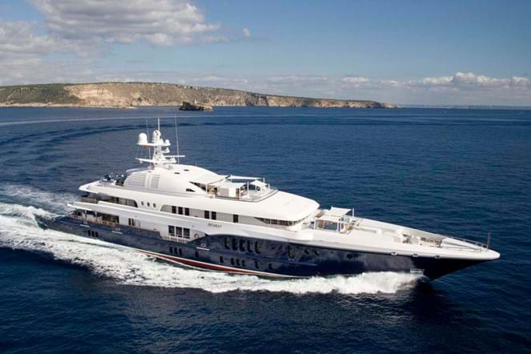

## Asking price: **EUR 59,500,000**

## Built: **2010 (refitted 2017), Nobiskurg, Germany**

## Length: **68.2m (223.6ft)**

## Guests: **14 in 6 cabins**

# Description:

SYCARA V had a focused design brief from an experienced Owner, who commissioned the Nobiskrug shipyard and designer Craig Beale to deliver a sleek, classy, and robust vessel with solid charter value. As a result of this collaboration the yacht was awarded the prestigious World Superyacht Award for 'Best Displacement Motor Yacht 60m - 84m' in 2011.

Exquisite accommodation is provided for up to 20 guests in eight cabins. SYCARA V has an elevator that runs from the accommodation deck up to the sun deck, and duel shell doors aft, housing a 31ft and a 23ft tender.

SYCARA V is not available for sale to US residents while in US waters.

# Key features:

* *Winner of the World Superyacht Award 2011 'Best Displacement Motor Yacht 60m - 84m'*
* *Exterior & Interior Design by Craig Beale/Pure Detail*
* *Accommodation for up to 20 guests in eight cabins (master suite, 4 guest King suites; 2 have additional single beds and Pullman, and 1 twin cabin with Pullman berth)*
* *Twin Caterpillar 3516 HD, 2200hp engines*
* *Max speed 16 knots and cruising speed 12.5 knots*
* *Range 6150 NM @ 12.5 knots*
* *Accommodation for 19 crew*
* *Lloyd's class, LY3, MCA compliant*